**Virginia Motorsports Technology Committee**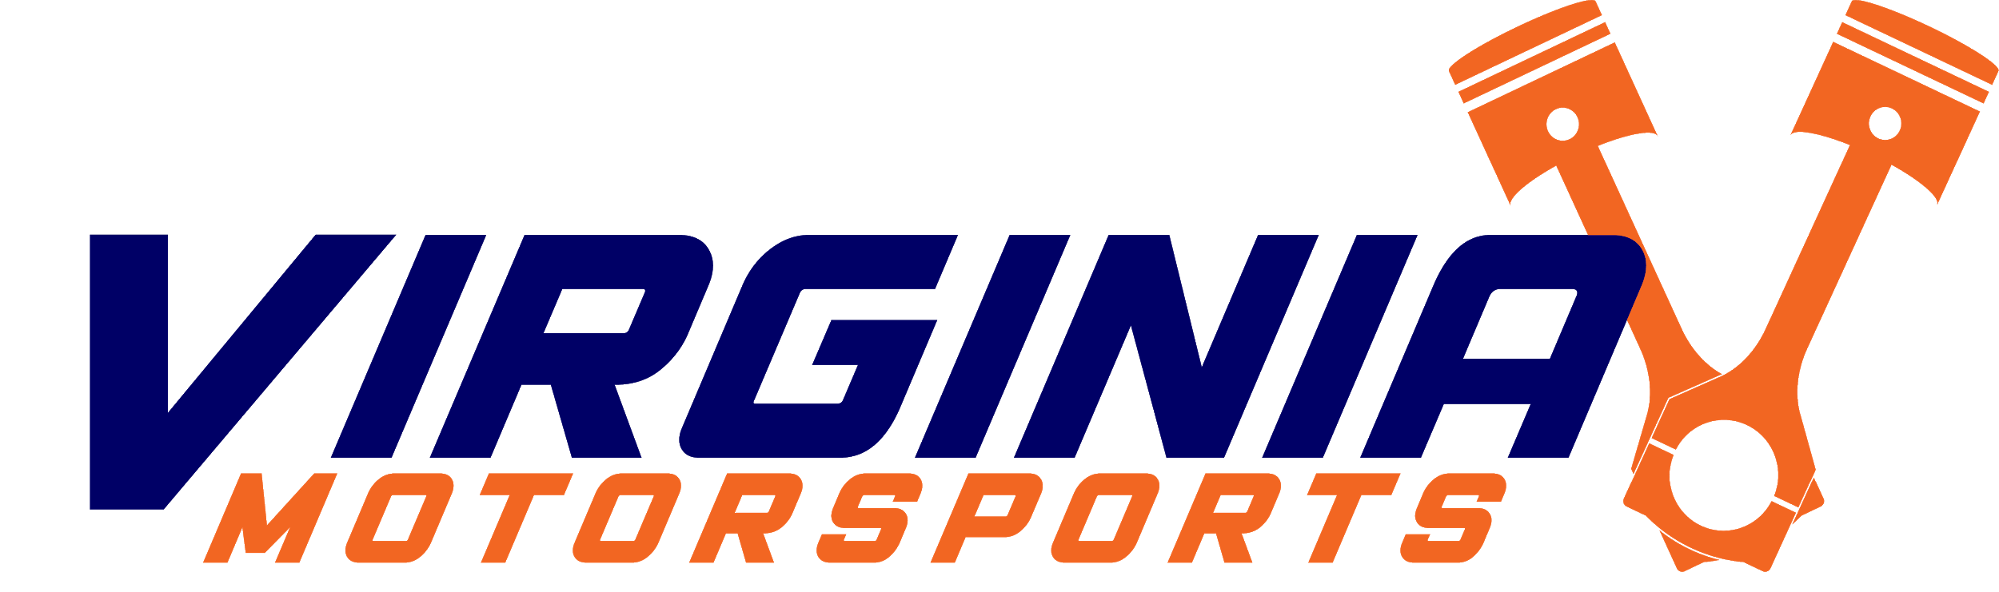

Meeting Agenda & Minutes

*Date and Time*: 11/15/2020 @ 4 PM

*Next meeting*: ??/??/2021

**Agenda**

1. Discussion & Other Topics
   1. Borrowed Equipment
      1. Return before heading home from break!
         1. I can swing by and pick it up
   2. Updates on projects
      1. Vishal (Inventory)
         1. Inventory Sheet done
         2. Working on barcode generator document
      2. Daniel (Digital Signing)
         1. Not much luck on Digital Signing, stick with what we have right now
         2. Working on processing the digitized waivers
         3. Working on shop page
      3. Will (Wiki)
         1. Make/find guide on how to add stuff to wiki (as a new user)
         2. Stylize wiki
         3. Look into web services to host wiki (AWS?)
      4. Noal (Display/OS(?))
      5. Bill (Drone)
      6. Yulie (Templates)
   3. Next Meeting